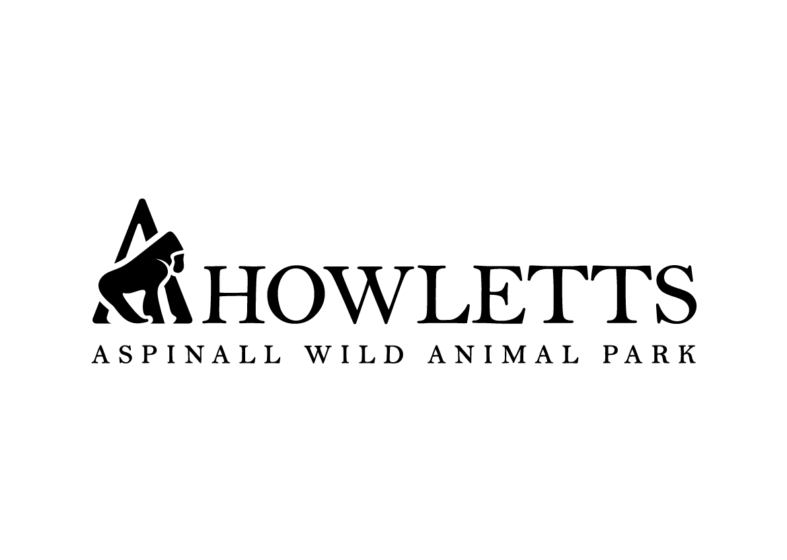

Filming/Photography/Recording Application
with
Port Lympne Hotel & Reserve and Howletts Wild Animal Park
(The Howletts Wild Animal Trust - HWAT)

THIS IS NOT A PERMIT TO FILM

Please complete the application form and email to amandam@aspinallfoundation.org or post to
Amanda McCabe, Communications Department, Port Lympne Hotel & Reserve, Lympne, Nr Ashford, Kent CT21 4PD

PERSONAL DETAILS

Name: | Job Title: | Telephone:
Fax: | Email:

COMPANY DETAILS

Company Name and Address:

Area of Business:

DETAILS OF SHOOT
Please mark with a tick or cross where applicable:

SITE: | Port Lympne Reserve |  |  | Howletts Wild Animal Park
CREW NO: | 1-5 | 6-12 | 13-20 | 21-40 | 41-70+
ACTIVITY: | Film |  | Photography |  | Sound
Genre:

Preferred Date & Time:

Which locations:

Please state when and where your activity will be printed or broadcast:

Please give a brief description of the project / proposal:

Type of equipment to be used:

