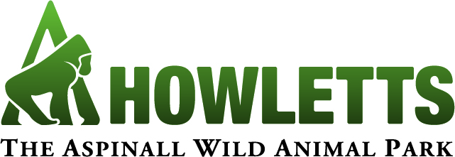
School Booking Form
Date of Visit:* |  |  |  | Time of Arrival: |  |  | Time of Departure:
Name of Organiser:
Name of School:
Address:
 |  |  |  |  |  | Postcode:
e-mail address:
Contact Number:
Where did you hear about us?

Will you be purchasing lunch onsite? | Yes |  | No |  | Maybe

Will you visiting the Gift Shop? | Yes |  | No |  | Maybe
Please see below to pre-order goody bags

Payment Methods:
Payment on the day |  | Credit/Debit Card |  | Cheque (enclosed) |  | Invoice
Email address for invoice if different from above:

ADMISSION
 | Price per person | Qty | Age | Total (£)
School Children (Aged 2-15) | £8.00
Students (Aged 16+) | £9.00
Free Teachers/Supervisors | 1 FREE for every 7 students*
Additional Teachers/Supervisors | £8.00
Treetop Challenge (Minimum height 1.2m, maximum weight 18 stone) | Group 20+ - £5 each  Under 20 - £100 to hire
Animal Adventure Challenge  (Maximum height 1.2m) | £1.50 per head for 20 min play session
Howlectures** | Costs vary
Goody Bags | £2.50 / £3 / £5
Total Cost:
* One teacher per seven pupils (excludes pupils holding passports) is free. Teachers must supervise pupils at all times.
** Please see form below for information on educational talks and workshops offered in the Howlectures programme and how to book your Howlecture.
I accept responsibility for the children in my party and ensure they will be supervised at all times.
Signed: |  | Print Name: |  | Date:

Please return booking forms via:
Email: zoer@aspinallfoundation.org Tel: 01303 264647 Fax: 01303 264944
Post: School Bookings, Port Lympne Reserve, Lympne, Hythe, Kent CT21 4PD

Book your Howlectures!

Add to your school visit by booking an additional educational session by one of our presenters. Choose your topic below. If you would like a talk on a topic not listed below, please call 01303 264647 to discuss your requirements.
 | Preferred Animals: | Price: | QTY | Total (£)
Habitats & Adaptations* (30mins) | Not Applicable | £40.00
Conservation* (30mins) | Not Applicable | £40.00
Leisure & Tourism (30mins) |  | £40.00
Enclosure Talk* (45mins) |  | £45.00
Hungry Hunters Talk* (45mins) | Not Applicable | £45.00
Monkey Mayhem Talk* (45mins) | Not Applicable | £45.00
Enrichment Workshop** (45mins inc talk as enrichment goes in) |  | £40.00
Adaptation Workshop** (45mins) |  | £45.00
30 Minute Animal Guided Tour* |  | £35.00
1 Hour Animal Guided Tour* |  | £50.00
2 hour Animal Guided Tour* |  | £75.00
Total Cost (Please add to above form)

*Please note that all education sessions apart from the Enrichment or Adaptation Workshops are for up to 30 pupils.
** Enrichment and Adaptation workshops are for 15 pupils

So we can plan your session appropriately, please can you advise us of any behavioural or physical needs, allergies or anything else you feel is relevant:
Please return booking forms via:
Email: zoer@aspinallfoundation.org Tel: 01303 264647 Fax: 01303 264944
Post: School Bookings, Port Lympne Reserve, Lympne, Hythe, Kent CT21 4PD

School’s Payment Form

I enclosed a cheque (please make payable to The Howletts Wild Animal Trust)
Please charge my credit / debit card

School Name
Card Number: |  | Start Date:
Security Number: |  | Expiry Date:
Cardholder Name: |  | Signature:

Email: zoer@aspinallfoundation.org Tel: 01303 264647 Fax: 01303 264944
Post: School Bookings, Port Lympne Reserve, Lympne, Hythe, Kent CT21 4PD

